COURSE: Artificial Intelligence
PROJECT BY:
Bakhtawar Memon 24108111

PROJECT TITLE:
NLP based resume ranking system
VISUAL STUDIO FOR PROJECT
SOFTWARE AND TOOLS:
.1.6 GHz or faster processor
.4 GB RAM, 20 GB available hard disk space
. Windows 7 or later
. Python
. Stream lit
. Pandas and NLTK
1: Text Preprocessing:
Before we start looking into resumes, we first clean the text so the system can understand it more clearly. Raw resume data mostly includes extra characters and common words that don’t really add value to the analysis, so removing them would help to improve accuracy.
In our project we used few simple but important techniques:
Lowercasing: we convert all into lowercases to ensure that words like “Python” and “python” are treated as the same, avoiding unnecessary duplication.
Noise Removal:We remove all non-alphabetic characters, such as numbers, symbols and special characters, using regular expressions. This helps eliminate irrelevant information from the data
Tokenization: The text is broken down into individual words. This makes it easier to process and analyze each word separately.
Stop-word Removal:Common English word like “and”, “the”, “is” removed because they don’t carry meaningful information and only add noise to the data.
This cleaning process makes the resume data much more structured and useful for further analysis
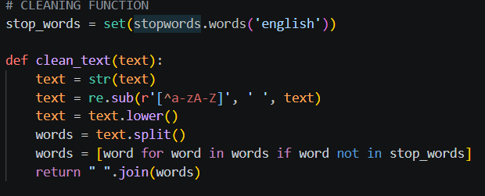
2.STOPWORDS REMOVAL (NLTK):
NLTK is used to filter out common English words that don’t carry much meaning so the model concentrate on the more important and relevant terms in the text.
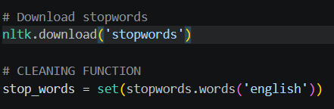
3.TF-IDF VECTORIZATION:
Converts text into numerical form so it can be processed by system.
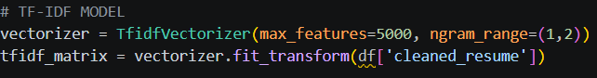
4.STREAM LIT UI:
Stream lit is used to build user interface
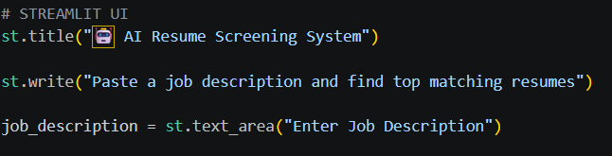
5.CLEAN JOB DESCRIPTION AND COSINE SIMILARITY:
Cosine similarity is used to check how closely two pieces of text match by comparing them as vector. A higher score means the resume is more relevant to the job description.
To make fair comparison, the job description entered by user goes through the same cleaning the process as the resumes. After that, it is converted into a TF-IDF vector, which allows it to be accurately compared with resume data.
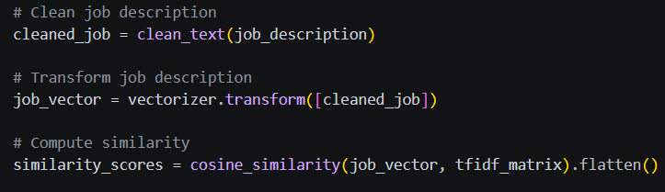
6.BAR CHART VISUALIZATION:
A bar chart is used to visually display the similarity scores of the top candidates, making it easier to compare their results.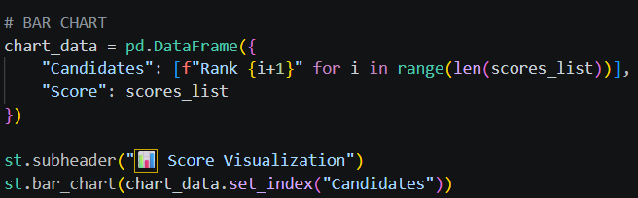
7.RESULTS:
The system successfully matches resumes with job description and ranks them based on similarity scores.
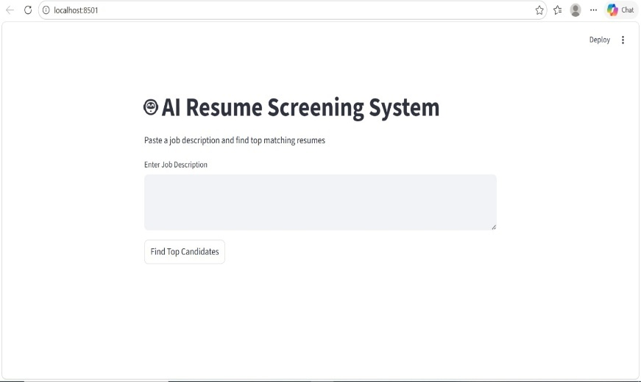
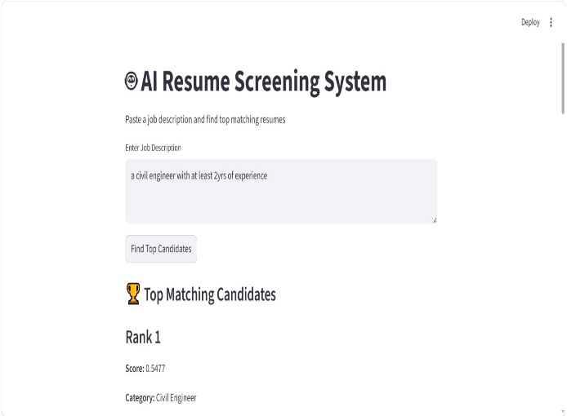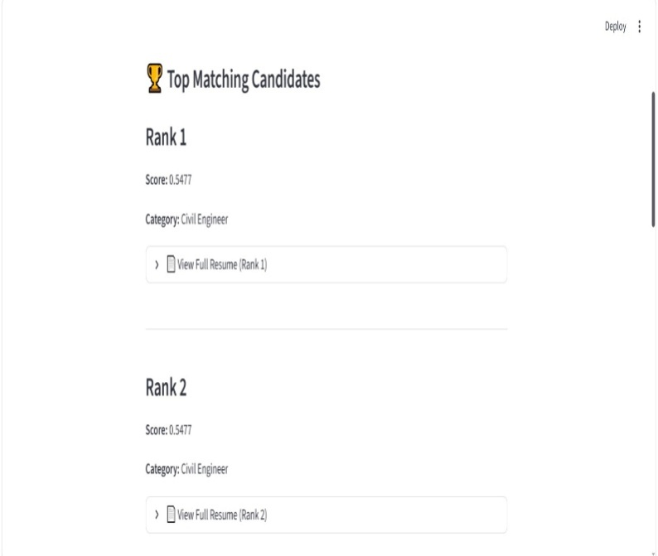
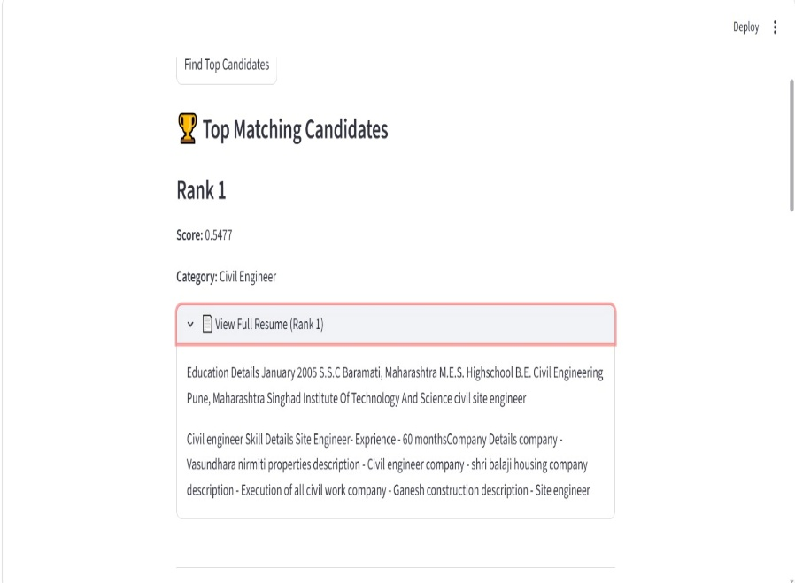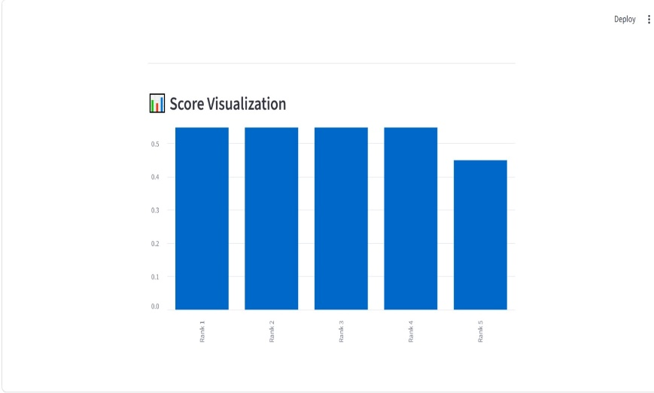
8.LIMITATIONS:
Based on keywords matching TF-IDF.
Does not understand deep meaning or context.
It depends upon dataset quality.
9.CONCLUSION:
The AI resume screening system streamlines the resume evaluation process by using preprocessing techniques along with TF-IDF and cosine similarity. It automatically compared resumes with job description and helps shortlist the most relevant candidates quickly and efficiently.

